 **Screw the lid into place**

Save Water

Keep our Waters Clean

**Friends of the Occoquan (FOTO)**

**Tel.  703 624-7124 or**

**703 674-7847**

Email: [foto@friendsoftheoccoquan.org](mailto:foto@friendsoftheoccoquan.org) Web Site: [www.friendsoftheoccoquan.org](http://www.friendsoftheoccoquan.org/)

How to Make a Rain Barrel

Presented by

Friends of the Occoquan

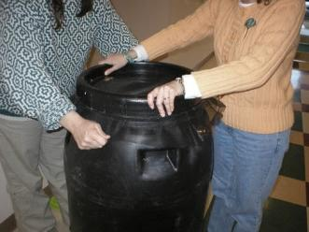

**Setting your Rain Barrel up at Home**

**Decide what you will be using your rain barrel for. Level the dirt under your downspout and add some sand. Remember rain barrels need to be higher than ground level for water pressure. Use bricks, cinderblocks or treated wood to raise barrel. Measure and cut off downspout. Leave room to reattach the downspout end piece. Attach a hose to your overflow hole and set your rain barrel in place. Next, attach the downspout piece. Decorate and landscape around your barrel.**

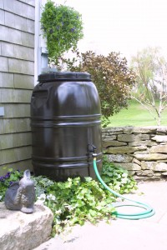

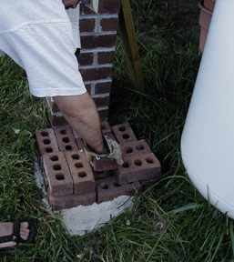 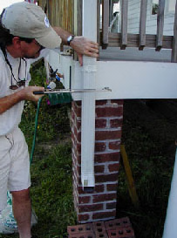

**Helpful Tips and Reminders**

Rain Barrel water is not for cooking or drinking.

Keep the screening on your barrel to avoid mosquito breeding.

The higher the barrel the greater the water pressure.

Disconnect the barrel in winter.

**For more information on Rain Barrels visit**

**Clean Virginia Waterways**

**http://www.longwood.edu/cleanva/**

**About Your Rain Barrel**

Your 55 gallon barrel is a food grade pickling barrel from Mount Olive Pickle Company. Each barrel comes with the hardware to complete your rain barrel. Tools, hoses, and downspout not included.

**Tools and supplies you will need**

Safety glasses, gloves, power drill with 1’’hole bit, pliers or wrench to tighten washers, scissors, screwdriver, hacksaw to shorten downspout, file, caulking and paper towels.

**\*Photos and information provided by**

***Clean Virgina Waterways***

**How to Make your Rain Barrel**

**Before you begin rinse out and dry barrel.**

**You will need a friend on hand to help you.**

**Drill a hole near the bottom of the barrel. File off excess debri.**

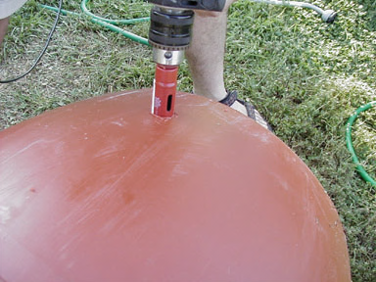

**Caulk around the outside of the hole.**

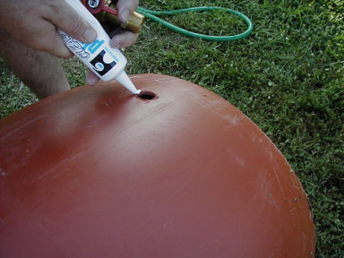

**Screw faucet in (note washer). Keep faucet straight as you screw it in. Have someone to help you hold the barrel steady.**

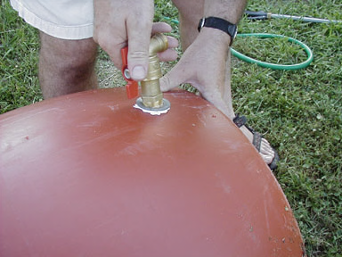

**Caulk inside and put washer in place, then the lock nut.**

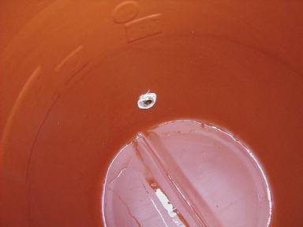

**You will need to crawl inside your barrel to caulk, and place in the lock nut. Tighten lock nut with pliers. Flashlight and paper towels are helpful.**

**The faucet is now connected.**

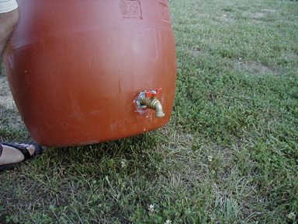

**Drill a hole towards the top of your barrel for the overflow.**

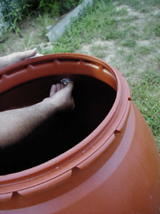

**Screw in the adapter using a wrench, making sure to protect the threads. Caulk the inside, place in lock nut. Use pliers to tighten, making sure to cover threads with a rag or pipe cap to prevent damage.**

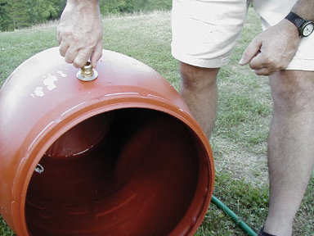

**If your screen is not precut, cut the screen for your barrel. A screen will prevent mosquito breeding. Cut your screen larger than the barrel lid.**